hi Don,

Im wondering if its possible to have the sample plans (or Lot templates seen in this window) to be split up into more options.

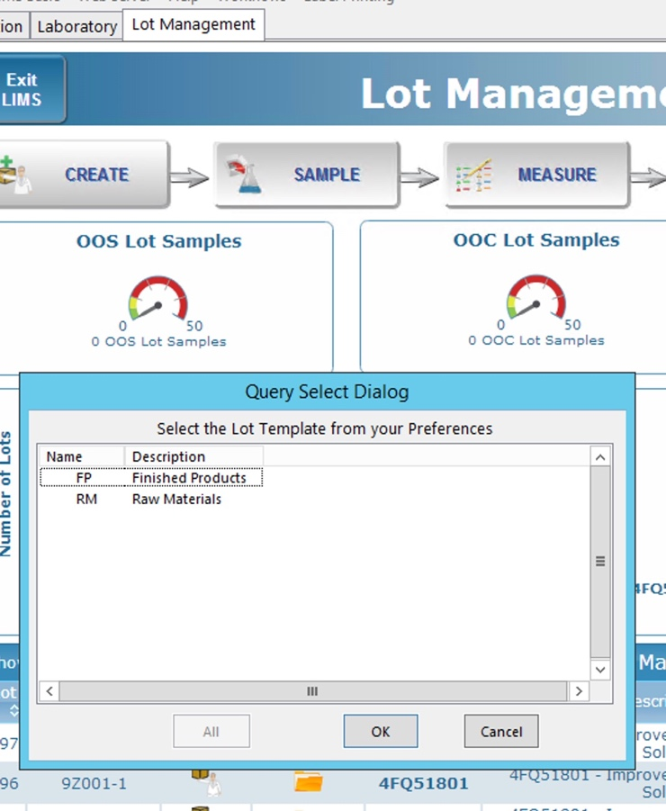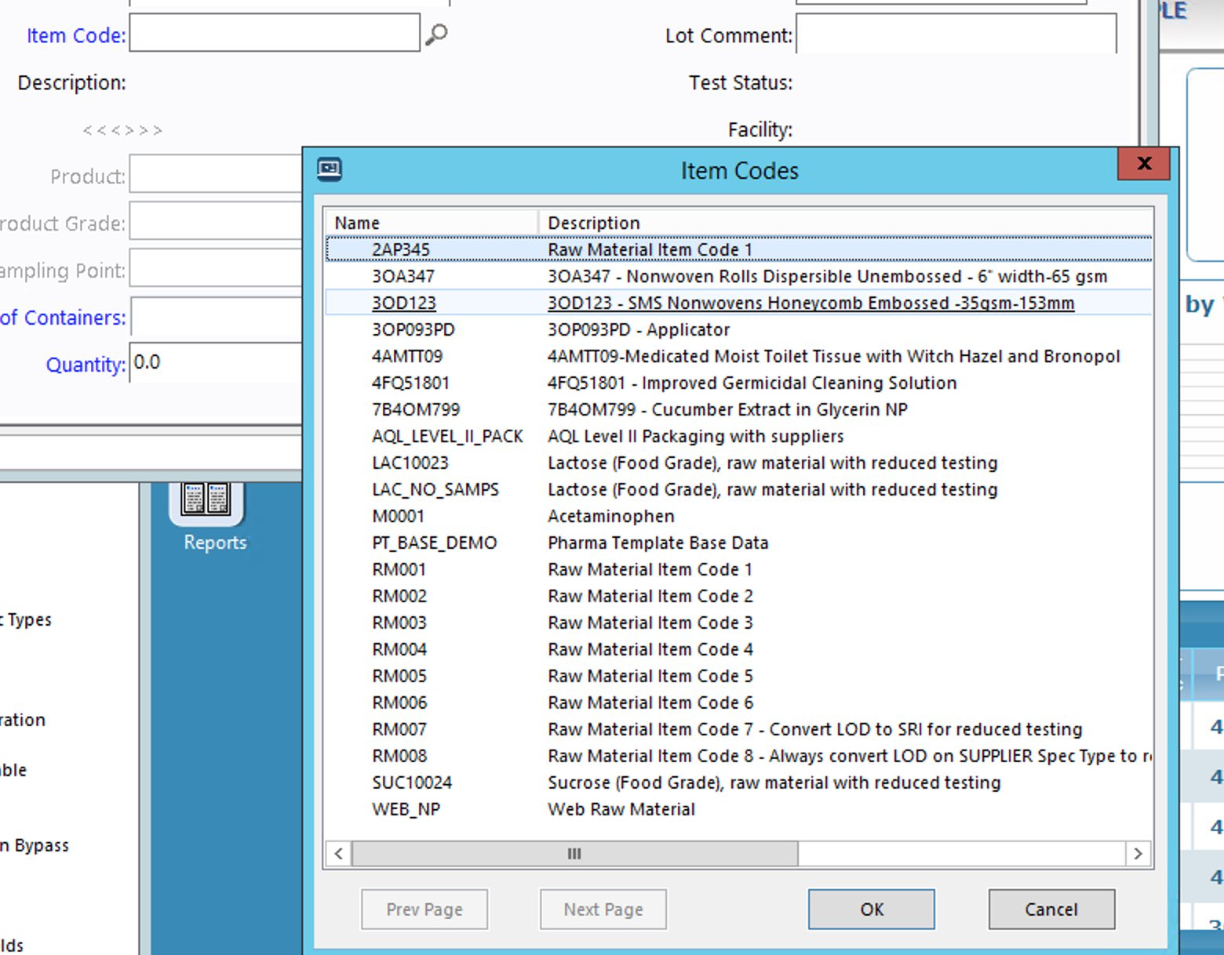

It would help limit the number of items to sort through in the Item Codes window:

But also because categories of products are logged in by different people at different times and often tested separately in the lab.

here some categories along with the expected number of Item Codes being imported/used.

**[96] Bulk Liquid** (usually entered by the Analyst doing the testing)

* Summary Tab
  + **Lot Name**
  + **Item Code / Product**
  + Tank
  + Port
  + Shift
  + T-M-B
  + **DOM [Default: today]**
  + **Retest / expiration date**
  + Comment
* Samples Tab  
  + List of previous samples from the lots of the same item code?

**[214] Raw Chemical** (usually entered by Nixon or an Analyst)

* Summary Tab
  + **Lot Name**
  + **Item Code / product**
    - **Supplier**

**Supplier Vendor Lot**

* + **Date of sample [Default: today]**
  + **Reassay / Exp Date**
  + Number of containers [Default: 1]
  + Quantity [Default: 100mL]
  + Comment
* Samples Tab
  + List of previous samples from the lots of the same item code?

**[1026] Component** (usually entered by a QC tech (Stephen Benjamin) or an Analyst)

* Summary Tab
  + **Lot Name**
  + **Item Code / product**
    - **Supplier**

**Supplier Vendor Lot**

* + **Date of sample [Default: today]**
  + Comment
* Samples Tab
  + List of previous samples from the lots of the same item code?

**[223] Finished Product** (usually entered by QA department and a Analysts composites samples before testing )

* Summary Tab
  + **Lot Name**
  + **Item Code / product**
  + **Production date [Default: today]**
  + Comment
* Samples Tab
  + List of available samples to composite?

**[223] Finished Product** (usually entered by QA department and a Analysts composites samples before testing )

* Summary Tab
  + **Lot Name**
  + **Item Code / product**
  + **Production date [Default: today]**
  + Comment
* Samples Tab
  + List of available samples to composite?

**[20+] Standards** (Not Currently Tracked in our LIMS but will be entered the Analyst who prepared it and have to be linked to the Bulk Liquid or Finished Products it was used for)

* Summary Tab
  + **Standard Name**
  + **Analyst name [Default: USER]  
    Test Method used**
  + **Prep date [Default: today]**
  + **Exp Date**
  + Comment